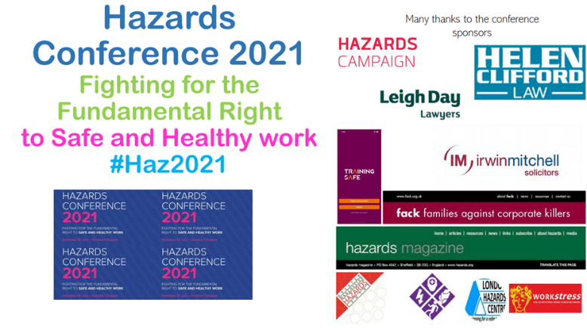
13.15–14.15 Supporting workers and their families seeking justice and health and safety enforcement
Chair: Hilda Palmer, Facilitator of FACK, workers at Greater Manchester Hazards Centre since 1987, member of Hazards Campaign Safety and Health Practitioner ‘Most influential H&S person 2020 https://tinyurl.com/brn59cbz

Speakers
- Sam Atkinson, Chef, FACK member, his house was destroyed on 8th July 2020 when an unsafe crane fell on it, killing his great aunt June Harvey and severely traumatising Sam and his mum Jacqueline.
Leaflet: https://tinyurl.com/n3nax436 See film of the vigil Sam organised on the first anniversary of June’s death 8.7.21 on Sam’s Facebook Sam’s page, or on Families Against Corporate Killers Facebook group..

- Louise Adamson Founder FACK er, Scottish Hazards and teller of Michael’s Story to companies, managers and workers.
Safety and Health Practitioners ‘Most influential person in health and safety 2018’ https://tinyurl.com/4dcnjp8k and Hazards Campaign Statement: https://tinyurl.com/4kev3bn5
Louise website: Michael’s Story: https://michaels-story.net/ Twitter: @michaels_story

- Keith Cundall, Senior Associate Solicitor Irwin Mitchell Solicitors, FACK supporter and has represented many FACK families at inquests https://tinyurl.com/v8x2ru87

- Phil James, Institute for Employment Rights, IER, Professor of Employment Relations at Middlesex University @IERUK https://www.ier.org.uk/ Editor of ‘HSE and Covid at work: ‘A case of regulatory failure HSE and Covid at work: A case of regulatory failure’ - IER: https://tinyurl.com/fuxd3wfs Phil’s presentation: https://tinyurl.com/4esu3dv3

Information and links
Families Against Corporate Killers, FACK, is a project of the Greater Manchester Hazards Centre which grew out5 of Bereaved by Work in the North West. For more information see https://gmhazards.org.uk/index.php/fack/ and http://www.fack.org.uk/ Hazards Magazine articles about FACK www.hazards.org Join Facebook: Families Against Corporate Killers https://www.facebook.com/groups/16054748370

The campaign for a Fundamental Right to safe and healthy work is so that no-one should ever die just for going to work to earn a living. Employers are under a legal duty to provide workplaces as free from risks to the health safety and welfare of employees and others who may be harmed as is reasonably practical. Everyone should be able to go to work and come home alive and well, not injured or made ill by exposure to physical danger or toxic factors at work. But in fact work kills hundreds of people every year, not in freak accidents but due to employers’ negligence and the Governments that do not make them comply with health and safety law to provide safe and healthy workplaces. The HSE only counts and publishes a fraction of work-related deaths but the Hazards Campaign in ‘The Whole Story’ https://tinyurl.com/7v6s4d5j provides more accurate estimates of around 1,500 killed in work-related incidents, 50,000 dying from illnesses caused by work, or around 140 a day. Even though their figures are not the total, the HSE’s latest fatality figures at 142 are 25% up from last year which in a pandemic when much non-essential work was meant to be closed down, and millions were working from home is extraordinarily shocking. And of course that figures does not include all those workers dying of Covid caught at work.
.FACK was set up in 2006 by families of those killed by workplace negligence because when someone you love is killed at work the lack of support is horrendous. No help from Victim Support as not considered victims of crime, no funding for legal representation at the inquest, often no financial compensation especially for people with no dependents and if not in a union often no idea of what to do next. The it can take years for the investigation and judicial process to provide any sort of answers as to how and why they died, or any justice from the penalties of prosecutions if they are even taken. FACK sits with people in their darkest hour and tries to help them speak truth to power. FACK provides support from people who have been through this process, plus information, advice and advocacy through the investigation, inquest and press for the highest possible charges and prosecution as well as campaigning for an end to all preventable deaths. We try to ensure that families have legal representation at inquest as the employers will have barristers or QCs and for justice we need to ensure equality of arms.
Our campaigning to prevent future deaths includes telling the stories of those killed and publicising the impact on their families, by taking part on International Workers Memorial Day 28th April every year to Remember the Dead and Fight for the Living, and demanding stricter enforcement on employers, for more rights for workers and stricter laws, and fighting against any deregulation of health and safety. This included lobbying for the Corporate Manslaughter and Corporate Homicide Act 2007 which unfortunately is not the law we fought for, see http://www.fack.org.uk/ press release ‘What about the workers? Families of workers killed by employers’ negligence feel bitterly betrayed by Corporate Manslaughter Bill’. There have only been 30 prosecutions since 2008, and more people go to jail every single year for hurting animals that have ever gone to prison for killing a worker. No justice, no peace and no end to the workplace killing.
Founder Members of FACK:
Dawn and Paul Adams – son Samuel Adams aged 6 killed at Trafford Centre, 10th October 1998
Linzi Herbertson -husband Andrew Herbertson 29, killed at work in Oldham, January 1998
Mike and Lynne Hutin – son Andrew Hutin 20, killed at work at Corus, Port Talbot on 8th Nov 2001
Mick & Bet Murphy – son Lewis Murphy 18, killed at work in Brighton on 21st February 2004
Louise Adamson – brother Michael Adamson 26, killed at work ion Aberdeen, on 4th August 2005
Linda Whelan – son Craig Whelan 23, (and Paul Wakefield) killed at work in Bolton on 23rd May 2002
Dorothy & Douglas Wright – son Mark Wright 37, killed at work in Deeside on 13th April 2005
Read their stories FACK www.hazards.org and watch the Founder FACK ers tell their stories in ‘Face the FACKs: the Human Face of Corporate Killing’ DVD dvd-cover-final.pdf (gmhazards.org.uk) which can also be watched here: Face the FACKS Part 1: https://www.youtube.com/watch?v=IX4L-zWV_sA Part 2: https://www.youtube.com/watch?v=e-i_6IVJ0ls Part 3: https://www.youtube.com/watch?v=c4l0UnnLYBU;
Part 4: https://www.youtube.com/watch?v=K3om3Qwpj5I

We know that what keep workers safe at work are strong laws, strictly enforced and strong active trade unions. Over the last several decades deregulatory governments especially since 2010 have waged war on all three of those factors calling strong health and safety i ‘pointless red tape’. The result is that the Hazards Campaign claimed in 2019 election manifesto that the health and safety system in Britain is broken and most at risk workers can’t get their right to safe, healthy workplace enforced https://tinyurl.com/4avv8c2u
Health and safety is all about inequality. The lower your wage, the more likely you are to be made ill, injured and killed at work and to live a shorter, less healthy life that those on higher income. Add in ethnicity, sex and disability discrimination and work becomes more toxic: ‘Fair enough: we are all sickened by inequality at work’ https://www.hazards.org/vulnerableworkers/ituc28april.htm
And so it has proved with Covid. Rory O’Neil, editor of Hazards Magazine said the Pandemic didn’t cause the crisis in health and safety, it merely exposed it. And the Institute for Employment Rights produced a book: ‘HSE and Covid at work: A case of regulatory failure edited by Phil James, which analyses the appalling failure of the HSE to protect workers in what is the biggest occupational health and safety crisis in its history https://tinyurl.com/fuxd3wfs
Hazards Magazine www.hazards.org @hazardsmagazine @hazardseditor E mail sub@hazards.org
Facebook Hazards Magazine: https://www.facebook.com/groups/85480113308 E mail sub@hazards.org
Hazards Campaign www.hazardscampaign.org.uk @hazardscamapign @jnewsham
Facebook: We didn’t vote to die at work – Hazards Campaign https://www.facebook.com/groups/123746101003963
Email info@hazardscampaign.org.uk janet@gmhazards.org.uk
GMHC website: https://gmhazards.org.uk/ Face Book https://www.facebook.com/GreaterManchesterHazardsCentre
Twitter: @CentreGreater Email mail@gmhazards.org.uk janet@gmhazards.org.uk
https://drive.google.com/file/d/1c94VJYpiWv-hdBTkPJ0aZBwap2oCX_Jy/view?usp=sharing

