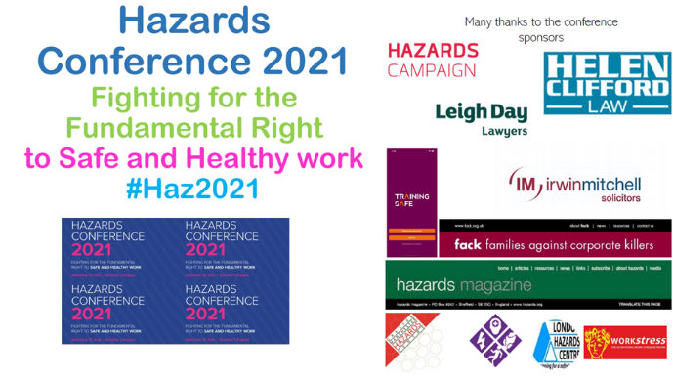
Workshop 5 Addressing the air pollution in our working environments
Facilitators
John James Wales TU Education tutor John.James@coleggwent.ac.uk
Hilda Palmer GM Hazards Campaign and Trade Union Clean Air Network TUCAN hilda@gmhazards.org.uk
This workshop Presentation: https://drive.google.com/file/d/13x3J2eiye2ESUPScUR8n1kE3rY9PH3R5/view?usp=sharing
TUCAN/Hazards Campaign Longer presentation on air pollution with lots of links
https://drive.google.com/file/d/1h1r4CrcyOzQm8vdKxqmd8LrO1ywQh9yd/view?usp=sharing
Hazards Campaign Thursday Talk - Clean Air Day and What is next for TUCAN? - YouTube https://www.youtube.com/watch?v=MVmlHdVUJEM; http://www.hazardscampaign.org.uk/blog/clean-air-thursday-talk-recordings-are-now-online;
Greener Jobs Alliance has a lot of info on air pollution and TUCAN, see https://www.bing.com/search?q=greener+jobs+alliance&cvid=4511adcbe69c4e6bb6dc817f76bce9a7&aqs=edge.0.0l2.5136j0j1&pglt=299&FORM=ANNTA1&PC=U531

If you are interested in Nitrogen dioxide and PM2.5 monitoring in your workplace contact TUCAN hilda@gmhazards.org.uk
We have access to monitors and support for Global Action Plan are keen to help workers carry out some monitoring. Even more keen to heard for manufacturing, food production and waste and recycling sites.
**********************************************************************************
A green recovery and a just transition | TUC https://www.tuc.org.uk/green;
The Wales TUC has published a new toolkit - Greener Workplaces for a Just Transition https://www.tuc.org.uk/greener-workplaces-just-transition-wales-tuc-toolkit-trade-unionists .It includes lots of tools and information to support trade unionists who want to take action on the climate and nature emergency and negotiate for greener and fairer workplaces. We have also set up a new Greener Workplaces Network https://www.tuc.org.uk/greener-workplaces-network-wales for trade unionists to meet and share best practice.
You can also read these case studies to find out more:
UCU environment rep shows the way to a greener, fairer future at Cardiff University https://www.tuc.org.uk/news/ucu-environment-rep-shows-way-greener-future-cardiff-university
Hospital UNISON rep creates a haven of green space for staff, patients and nature https://www.tuc.org.uk/news/hospital-unison-rep-creates-haven-green-space-patients-staff-and-nature
Prospect reps help workers at the IPO to 'climate-proof' their workplace https://www.tuc.org.uk/news/prospect-reps-help-workers-ipo-climate-proof-their-workplace

Info on Ventilation for Covid
TUC Webinar: Managing Ventilation as a Covid Safety Measure https://www.crowdcast.io/e/managing-ventilation-as?utm_source=profile&utm_medium=profile_web&utm_campaign=profile
Hazards Magazine Venting Factsheet – Covid is in the Air, Hands, face, space won’t cut it! : https://www.hazards.org/infections/venting.htm
Longer presentation on ventilation: https://drive.google.com/file/d/1bsPGscEVrSTKkmgEZw0iZW8EWBQWkesa/view?usp=sharing
Important contacts
Hazards Magazine www.hazards.org @hazardsmagazine @hazardseditor E mail sub@hazards.org Subscribe
Facebook Hazards Magazine: https://www.facebook.com/groups/85480113308 E mail sub@hazards.org
Hazards Campaign www.hazardscampaign.org.uk Sign up for updates @hazardscamapign @jnewsham
Facebook: We didn’t vote to die at work – Hazards Campaign https://www.facebook.com/groups/123746101003963
Email info@hazardscampaign.org.uk janet@gmhazards.org.uk
GMHC website: https://gmhazards.org.uk/ Face Book https://www.facebook.com/GreaterManchesterHazardsCentre
Twitter: @CentreGreater Email mail@gmhazards.org.uk janet@gmhazards.org.uk

